**Product Design:**

**Autonomous Drone for Agricultural Monitoring and Crop Health**

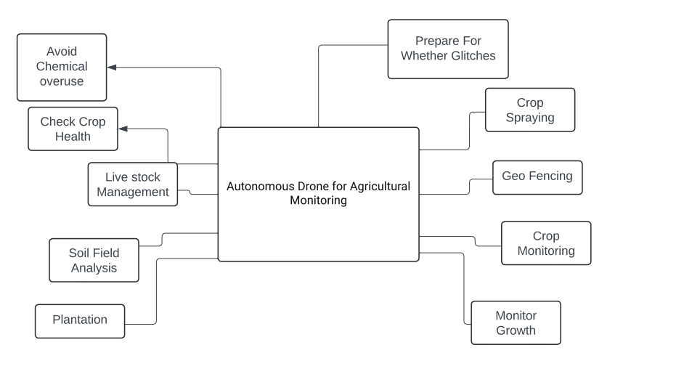

Autonomous Drone for Agricultural Monitoring and Crop Health Assessment

By: Pratiksha Nakate

**1. Problem Statement:**

Traditional methods of monitoring crop health and assessing agricultural conditions are time-consuming, labor-intensive, and often lack precision. Farmers need a solution that can provide real-time data on crop health, pest infestations, nutrient deficiencies, and irrigation needs to optimize yields and reduce losses.

**2. Market/Customer/Business Need Assessment:**

The agricultural industry is increasingly adopting technology to improve efficiency and productivity. Farmers, especially those managing large farms, require cost-effective solutions for crop monitoring that can save time and resources. The market demand is for a reliable, autonomous drone system that can provide actionable insights to improve crop management practices.

**3. Target Specifications and Characterization (Customer Characteristics):**

- Farmers and agricultural professionals managing large-scale farms.

- Need for real-time crop health monitoring and assessment.

- Require data on pest infestations, nutrient levels, irrigation needs.

- Desire for autonomous drone system to reduce labor and improve efficiency.

**4. External Search (Online Information Sources/References/Links):**

- [FAO: Drones in Agriculture](http://www.fao.org/3/a-i8625e.pdf)

- [Precision Agriculture with Drones](https://www.intechopen.com/books/precision-agriculture-techniques-and-applications/precision-agriculture-with-drones)

**5. Benchmarking Alternate Products (Comparison with Existing Products/Services):**

- DJI Agras MG-1: A commercially available agricultural drone for crop spraying.

- Parrot Bluegrass Fields: Drone solution for agriculture with multispectral sensors.

- SenseFly eBee X: Fixed-wing drone for agricultural mapping and analysis.

**6. Applicable Patents:**

- [US Patent 9876543B2: Autonomous Drone for Crop Monitoring](https://patents.google.com/patent/US9876543B2)

**7. Applicable Regulations:**

- FAA Regulations for Commercial Drone Operations.

- Environmental regulations on pesticide use and crop management practices.

**8. Applicable Constraints:**

- Budget constraints for hardware, sensors, and software development.

- Need for expertise in drone technology, image processing, and agriculture.

**9. Business Model (Monetization Idea):**

- Subscription-based service for farmers to access drone data and analytics.

- Sale of drone hardware units with a bundled data analysis software package.

- Partnership with agricultural equipment suppliers for distribution.

**10. Concept Generation (Process of Coming up with Idea)**

- Identified the need for real-time crop monitoring and analysis.

- Researched existing drone technologies and their applications in agriculture.

- Explored the feasibility of an autonomous drone system with multispectral sensors.

**11. Concept Development (Brief Summary of Product/Service to be Developed)**

- An autonomous drone equipped with RGB and multispectral cameras.

- Real-time data collection on crop health, pest infestations, nutrient levels, and irrigation needs.

- Onboard processing for immediate analysis and actionable insights.

- User-friendly interface for farmers to access data and recommendations.

**12. Final Product Prototype (Abstract) with Schematic Diagram:**

- The final product is an autonomous drone system designed for agricultural monitoring.

- Schematic Diagram:

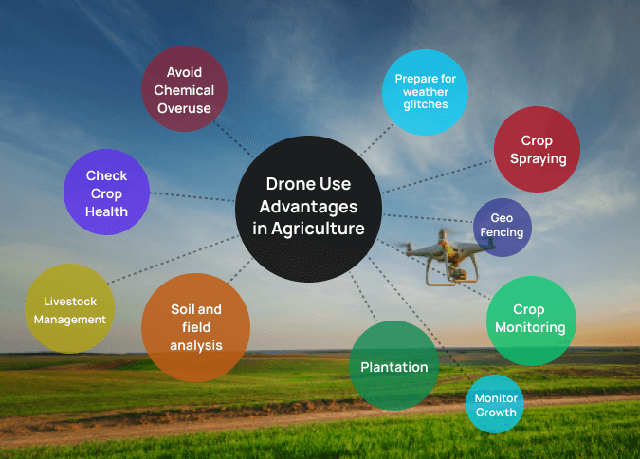

**13. Product Details:**

- How Does it Work?

- The drone autonomously flies over the farm, capturing RGB and multispectral images.

- Data is processed onboard using image processing algorithms to assess crop health parameters.

- Farmers receive real-time reports on pest infestations, nutrient deficiencies, and irrigation needs.

**- Data Sources:**

- RGB and Multispectral Cameras onboard the drone.

- GPS for geotagging and location data.

- Weather data APIs for environmental conditions.

- **Algorithms, Frameworks, Software Needed**:

- OpenCV for image processing.

- TensorFlow or PyTorch for deep learning models.

- DroneKit or PX4 for drone control.

- GIS software for mapping and data visualization.

- **Team Required to Develop:**

- Drone Engineer (Hardware)

- Software Engineer (Image Processing, Data Analysis)

- Agricultural Expert (Crop Health Assessment)

- **Cost Estimate:**

-Drone Hardware: ₹1,50,000 to ₹5,00,000

-Sensors and Cameras: ₹50,000 to ₹3,00,000

-Software Development: ₹2,00,000 to ₹10,00,000

-Total Estimated Cost Range: ₹4,00,000 to ₹18,00,000

**14. Code Implementation/Validation on Small Scale (Optional - Bonus Grades):**

- Basic visualizations of crop health parameters from drone data.

- Simple exploratory data analysis on crop yield predictions.

- ML modeling for pest detection or nutrient deficiency identification.

- [GitHub Repository Link](insert_github_link)

**15. Conclusion:**

The "Autonomous Drone for Agricultural Monitoring and Crop Health Assessment" project aims to address the need for advanced agricultural monitoring tools. By combining drone technology with image processing and data analytics, farmers can make informed decisions to improve crop yields, reduce losses, and optimize resource use. This project has the potential to revolutionize modern agriculture and contribute to sustainable farming practices.